# Sensors and Radio Test 1

What is the name of the sensor on the micro:bit which measures temperature?

A. Compass

B. Accelerometer

C. Thermometer

D. Bluetooth Antenna

ANSWER: C

What can a digital temperature sensor measure?

A. Temperature values within a range

B. A single status, for example if the temperature is above 25oC

C. A range of temperatures below 25oC

D. A range of temperature above 25oC

ANSWER: B

What will be the output from the following program if the temperature is 18 oC

A. Too cold!

B. Too warm!

C. Error

D. Nothing would be output

ANSWER: D

Which type of sensor would you use to automatically turn on a fan in a bathroom when the shower is used?

A. Infrared

B. Humidity

C. Temperature

D. Accelerometer

ANSWER: B

Which type of sensor could be used in a house alarm to detect movement?

A. Infrared

B. Humidity

C. Temperature

D. Accelerometer

ANSWER: A

What is the name of the type of algorithm which is used to encrypt data?

A. Encryption

B. Encryption Key

C. Cipher

D. Decryption Key

ANSWER: C

Why is it necessary to encrypt data when transmitting it?

A. It is quicker

B. It uses less of your data allowance

C. It makes it meaningless if someone intercepts it

D. So that the two communicating devices understand the rules

ANSWER: C

In which category of blocks will you find the code to send a string wirelessly to another micro:bit?

A. LED

B. Logic

C. Basic

D. Radio

ANSWER: D

What term is used to describe the type of code which includes a loop?

A. Sequence

B. Selection

C. Iteration

D. Function

ANSWER: C

What should be the first step when starting a new project?

A. Write down the success criteria

B. Create a test plan

C. Write down the algorithms

D. Create the code

ANSWER: A

What will the following code output?

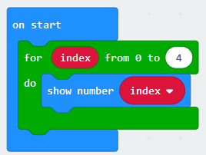

A. index index index index

B. 0 1 2 3 4

C. 0 1 2 3

D. 4 4 4 4

ANSWER: B

Freya would like to repeat the note 4 times. Where can she find the code to repeat this block?

A. Basic

B. Advanced

C. Loops

D. Logic

ANSWER: C

Stepan has written a simple program to greet his friends. Unfortunately he cannot get his code to run. What does he need to do to fix it?

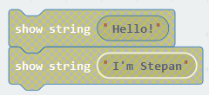

A. Place the code inside an on start loop

B. Place the code inside a forever loop

C. Place the code inside an ‘on button pressed’ block

D. Any of the above

ANSWER: D

Lucas has created a tune using blocks from the ‘music’ category. If he changes the Hz what does this result in?

A. The volume increasing

B. The volume decreasing

C. The tempo of the tune changing

D. The tone of the note changing

ANSWER: D

How many measurements of temperature will the code below take?

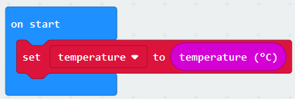

A. None

B. 1

C. 2

D. It will take endless measurements whilst the program is running

ANSWER: B

What is the name of the datatype which allows the micro:bit to show text?

A. Text

B. Integer

C. String

D. Real

ANSWER: C

What is the name of the type of image which is displayed on the LEDs?

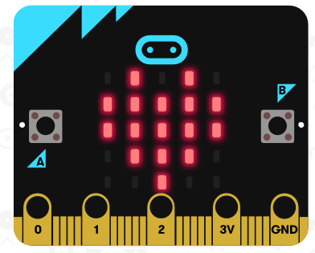

A. Image

B. Emoji

C. Icon

D. String

ANSWER: C

Which of the following blocks could be used to turn on a light when it is dusk?

A. Compass heading

B. Light level

C. Acceleration (mg)

D. Temperature

ANSWER: B

When we create a program we should code it to use as few lines of code as possible. What does this help to ensure?

A. Efficiency

B. Effectiveness

C. Error free

D. Engagement

ANSWER: A

What would be the output if Goals Team1 = 2 and Goals Team2 = 3?

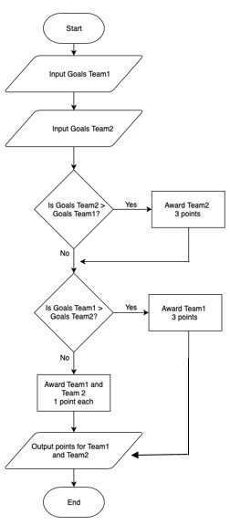

A. 3 0

B. 0 3

C. 0 0

D. Team1 0 Team2 3

ANSWER: B